***Solution Section* 4.3 – Polar Coordinates**

***Exercise***

Find the Cartesian coordinates of the following points (given in polar coordinates)



***Solution***

1. 

***Cartesian coordinates*** 

1. 

***Cartesian coordinates*** 

1. 

***Cartesian coordinates*** 

1. 

***Cartesian coordinates*** 

***Exercise***

Find the polar coordinates, , of the following points given in Cartesian coordinates



***Solution***

1. 

***Polar coordinates*** 

1. 

***Polar coordinates*** 

1. 

***Polar coordinates*** 

1. 

***Polar coordinates*** 

***Exercise***

Find the polar coordinates, , of the following points given in Cartesian coordinates



***Solution***

1. 

***Polar coordinates*** 

1. 

***Polar coordinates*** 

1. 

***Polar coordinates*** 

1. 

***Polar coordinates*** 

***Exercise***

Graph 

***Solution***

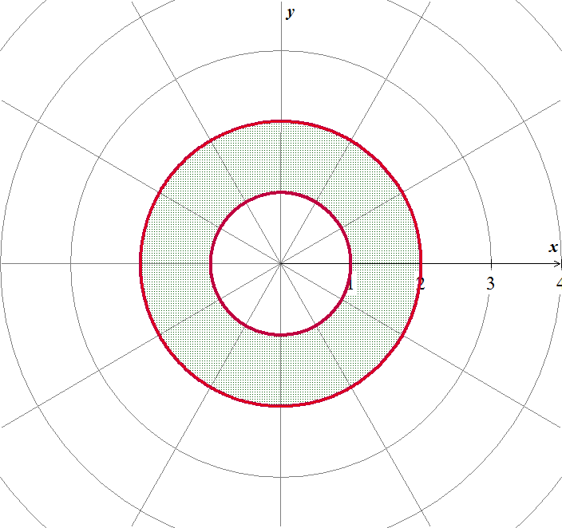

***Exercise***

Graph 

***Solution***

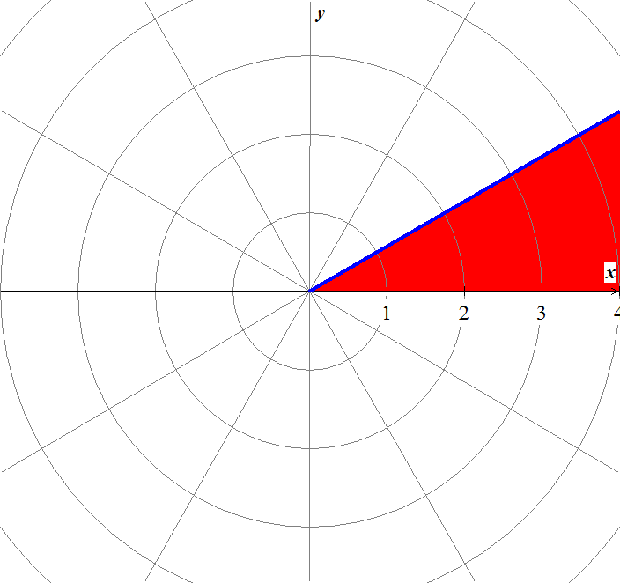

***Exercise***

Graph 

***Solution***

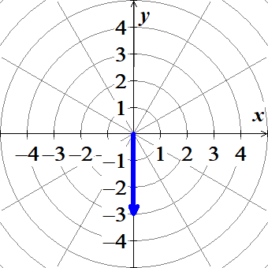

***Exercise***

Graph 

***Solution***

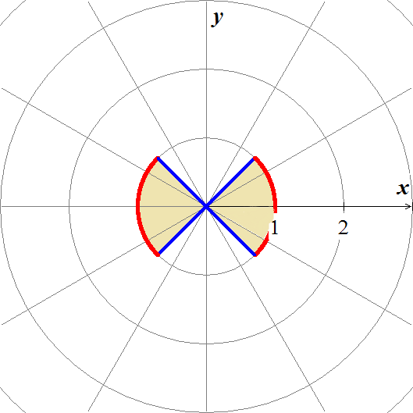

***Exercise***

Graph 

***Solution***

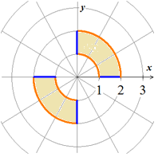

***Exercise***

Replace the polar equation with equivalent Cartesian equation and identify the graph 

***Solution***

, vertical line

***Exercise***

Replace the polar equation with equivalent Cartesian equation and identify the graph 

***Solution***

, horizontal line

***Exercise***

Replace the polar equation with equivalent Cartesian equation and identify the graph 

***Solution***



, vertical line through 

***Exercise***

Replace the polar equation with equivalent Cartesian equation and identify the graph 

***Solution***

, line with slope −1

***Exercise***

Replace the polar equation with equivalent Cartesian equation and identify the graph 

***Solution***









It is a circle with a center  and radius *r* = 2.

***Exercise***

Replace the polar equation with equivalent Cartesian equation and identify the graph 

***Solution***









It is a line with slope *m* = 2 and intercept *b* = 5

***Exercise***

Replace the polar equation with equivalent Cartesian equation and identify the graph 

***Solution***















It is a parabola with vertex (0, 0).

***Exercise***

Replace the polar equation with equivalent Cartesian equation and identify the graph 

***Solution***

 ***Power Rule***





Graph of the natural logarithm function

***Exercise***

Replace the polar equation with equivalent Cartesian equation and identify the graph 

***Solution***









The graph is 2 perpendicular lines through the origin with slopes −1 and 1,

***Exercise***

Replace the polar equation with equivalent Cartesian equation and identify the graph 

***Solution***













It is a circle with a center  and radius .

***Exercise***

Replace the polar equation with equivalent Cartesian equation and identify the graph 

***Solution***











It is a line with slope and intercept *b* = 10

***Exercise***

Replace the polar equation with equivalent Cartesian equation and identify the graph 

***Solution***





The graph: Line  with slope *m =* 2.

***Exercise***

Replace the Cartesian equation with equivalent polar equation 

***Solution***









***Exercise***

Replace the Cartesian equation with equivalent polar equation 

***Solution***









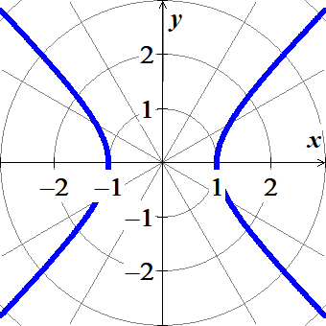

***Exercise***

Replace the Cartesian equation with equivalent polar equation 

***Solution***







***Exercise***

Replace the Cartesian equation with equivalent polar equation 

***Solution***



 





***Exercise***

Replace the Cartesian equation with equivalent polar equation 

***Solution***







***Exercise***

Replace the Cartesian equation with equivalent polar equation 

***Solution***













***Exercise***

Replace the Cartesian equation with equivalent polar equation 

***Solution***











***Exercise***

***a*)** Show that every vertical line in the *xy*−plane has a polar equation of the form 

***b*)** Find the analogous polar equation for horizontal lines in the *xy*−plane.

***Solution***

1. 





1. 







***Exercise***

Identify the symmetries of the curve. Then sketch the curve. 

***Solution***



Symmetric about the *x*-axis

 It is not symmetric about the *y*-axis

Therefore; it is *not* symmetric about the origin.

|  |  |  |  |  |  |  |  |  |  |  |  |  |  |
| --- | --- | --- | --- | --- | --- | --- | --- | --- | --- | --- | --- | --- | --- |
| |  |  | | --- | --- | | ***θ*** |  | | 0 | 0 | |  | 1 | |  | 2 | |  | 1 | |  | 4 | |  |

***Exercise***

Identify the symmetries of the curve. Then sketch the curve. 

***Solution***

 It is not symmetric about the *x*-axis

 It is symmetric about the *y*-axis

Therefore; it is not symmetric about the origin.

|  |  |  |  |  |  |  |  |  |  |  |  |  |  |
| --- | --- | --- | --- | --- | --- | --- | --- | --- | --- | --- | --- | --- | --- |
| |  |  | | --- | --- | | ***θ*** |  | |  | 0 | |  | .293 | | 0 | 1 | |  | 1.707 | |  | 2 | |  |

***Exercise***

Identify the symmetries of the curve. Then sketch the curve. 

***Solution***

 It is not symmetric about the *x*-axis

 It is symmetric about the *y*-axis

Therefore; it is not symmetric about the origin.

|  |  |  |  |  |  |  |  |  |  |  |  |  |  |
| --- | --- | --- | --- | --- | --- | --- | --- | --- | --- | --- | --- | --- | --- |
| |  |  | | --- | --- | | ***θ*** |  | |  | 1 | |  | 1.293 | | 0 | 2 | |  | 1.707 | |  | 2.707 | |  |

***Exercise***

Identify the symmetries of the curve. Then sketch the curve. 

***Solution***

 It is symmetric about the *x*-axis

 It is symmetric about the *y*-axis

Therefore; it is symmetric about the origin.

|  |  |  |  |  |  |  |  |  |  |  |  |  |  |
| --- | --- | --- | --- | --- | --- | --- | --- | --- | --- | --- | --- | --- | --- |
| |  |  | | --- | --- | | ***θ*** |  | | 0 | 0 | |  | 0.707 | |  | 0.84 | |  | 0.93 | |  | 1 | |  |

***Exercise***

Identify the symmetries of the curve. Then sketch the curve. 

***Solution***

 It is symmetric about the *x*-axis

 It is symmetric about the *y*-axis

Therefore; it is symmetric about the origin

|  |  |  |  |  |  |  |  |  |  |  |  |  |  |
| --- | --- | --- | --- | --- | --- | --- | --- | --- | --- | --- | --- | --- | --- |
| |  |  | | --- | --- | | ***θ*** |  | | 0 | 0 | |  | 0.707 | |  | 0.84 | |  | 0.93 | |  | 1 | |  |

***Exercise***

Identify the symmetries of the curve. Then sketch the curve. 

***Solution***

 It is symmetric about the *x*-axis

 It is symmetric about the *y*-axis

Therefore; it is symmetric about the origin

|  |  |  |  |  |  |  |  |  |  |  |  |  |  |
| --- | --- | --- | --- | --- | --- | --- | --- | --- | --- | --- | --- | --- | --- |
| |  |  | | --- | --- | | ***θ*** |  | |  | 0 | |  | 0.7 | |  | 0.84 | |  | 0.93 | |  | 1 | |  |

***Exercise***

Graph the lemniscate. What symmetries do these curves have? 

***Solution***

|  |  |  |  |  |  |  |  |  |  |  |  |
| --- | --- | --- | --- | --- | --- | --- | --- | --- | --- | --- | --- |
| |  |  | | --- | --- | | ***θ*** |  | | 0 | 2 | |  | 1.8 | |  | 1.4 | |  | 0 | |  |

 The graph is symmetric about the *x*-axis and the *y*-axis

⇒ The graph is symmetric about the origin.

***Exercise***

Graph the lemniscate. What symmetries do these curves have? 

***Solution***

|  |  |  |  |  |  |  |  |  |  |  |  |
| --- | --- | --- | --- | --- | --- | --- | --- | --- | --- | --- | --- |
| |  |  | | --- | --- | | ***θ*** |  | | 0 | 0 | |  | 1.4 | |  | 1.8 | |  | 2 | |  |

 The graph is symmetric about the origin.

 ⇒ The graph is *not* symmetric about the *x*-axis

 ⇒ The graph is *not* symmetric about the *y*-axis.

***Exercise***

Graph the lemniscate. What symmetries do these curves have? 

***Solution***

|  |  |  |  |  |  |  |  |  |  |
| --- | --- | --- | --- | --- | --- | --- | --- | --- | --- |
| |  |  | | --- | --- | | ***θ*** |  | |  | 0 | |  | .7 | |  | 1 | |  |

***Exercise***

Graph the limaçons is Old French for “snail”. Equations for limaçons have the form 

***Solution***

|  |  |  |  |  |  |  |  |  |  |  |  |  |  |  |  |  |  |
| --- | --- | --- | --- | --- | --- | --- | --- | --- | --- | --- | --- | --- | --- | --- | --- | --- | --- |
| |  |  | | --- | --- | | ***θ*** |  | | 0 | 1.5 | |  | 1.36 | |  | 1.2 | |  | 1 | |  | 0.5 | |  | −0.2 | |  | −0.5 | |  |

***Exercise***

Graph the limaçons is Old French for “snail”. Equations for limaçons have the form 

***Solution***

|  |  |  |  |  |  |  |  |  |  |  |  |  |  |  |  |  |  |  |  |
| --- | --- | --- | --- | --- | --- | --- | --- | --- | --- | --- | --- | --- | --- | --- | --- | --- | --- | --- | --- |
| |  |  | | --- | --- | | ***θ*** |  | | 0 | 0.5 | |  | 1 | |  | 1.2 | |  | 1.36 | |  | 1.5 | |  | 0.5 | |  | −0.2 | |  | −0.5 | |  |

***Exercise***

Graph the limaçons is Old French for “snail”. Equations for limaçons have the form 

***Solution***

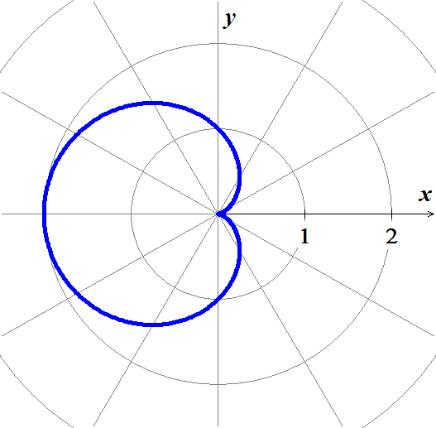

***Exercise***

Graph the limaçons is Old French for “snail”.

Equations for limaçons have the form 

***Solution***

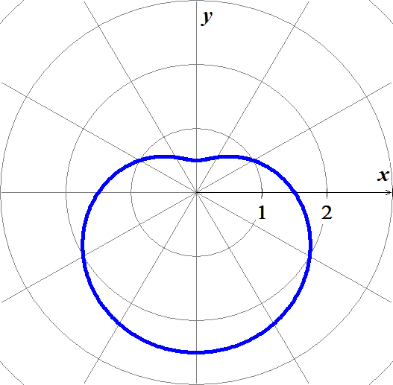

***Exercise***

Graph the limaçons is Old French for “snail”. Equations for limaçons have the form 

***Solution***

|  |  |  |  |  |  |  |  |  |  |  |  |  |  |  |  |
| --- | --- | --- | --- | --- | --- | --- | --- | --- | --- | --- | --- | --- | --- | --- | --- |
| |  |  | | --- | --- | | *θ* |  | | 0 |  | |  |  | |  |  | |  |  | |  |  | |  | 1 | |  |

***Exercise***

Graph the equation 

***Solution***

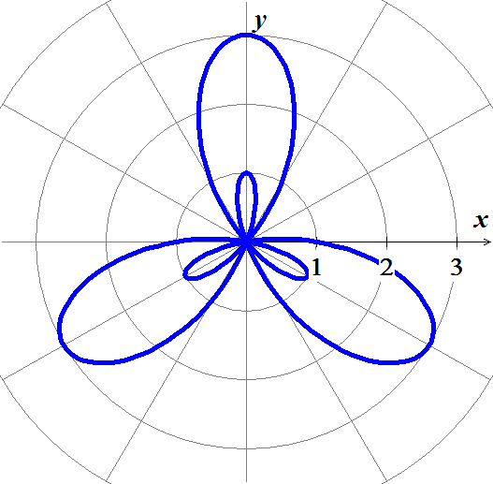

***Exercise***

Graph the equation 

***Solution***

 It is symmetric about the *x*-axis

|  |  |  |  |  |  |  |  |  |  |  |  |  |  |
| --- | --- | --- | --- | --- | --- | --- | --- | --- | --- | --- | --- | --- | --- |
| |  |  | | --- | --- | | *θ* |  | | 0 | 0 | |  |  | |  |  | |  | 0.75 | |  | 1 | |  |

***Exercise***

Graph the equation 

***Solution***

|  |  |  |  |  |  |  |  |  |  |  |  |  |  |  |  |  |  |  |  |
| --- | --- | --- | --- | --- | --- | --- | --- | --- | --- | --- | --- | --- | --- | --- | --- | --- | --- | --- | --- |
| |  |  | | --- | --- | | *θ* |  | | 0 |  | |  |  | |  |  | |  |  | |  |  | |  | 1 | |  | 1.5 | |  | 2 | |  |

***Exercise***

Graph the equation 

***Solution***

 It is symmetric about the *y*-axis

|  |  |  |  |  |  |  |  |  |  |  |  |  |  |
| --- | --- | --- | --- | --- | --- | --- | --- | --- | --- | --- | --- | --- | --- |
| |  |  | | --- | --- | | *θ* |  | | 0 | 0 | |  |  | |  |  | |  |  | |  | 2 | |  |

***Exercise***

Graph the nephroid of Freeth equation 

***Solution***

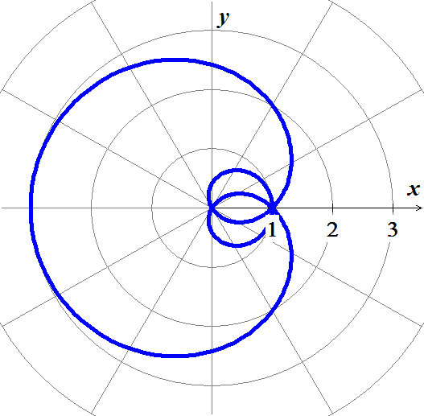

***Exercise***

Water flows in a shallow semicircular channel with inner and outer radii of 1 *m* and 2 *m*. At a point  in the channel, the flow is in the tangential direction (counterclockwise along circles), and it depends only on *r*, the distance from the center of the semicircles.

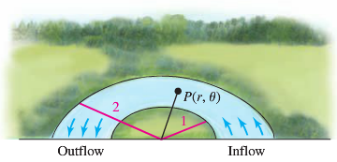

1. Express the region formed by the channel as a set in polar coordinates.
2. Express the inflow and outflow regions of the channel as sets in polar coordinates.
3. Suppose the tangential velocity of the water in *m/s* is given by , for . Is the velocity greater at  or ? Explain.
4. Suppose the tangential velocity of the water is given by , for . Is the velocity greater  or ? Explain.
5. The total amount of water that flows through the channel (across a cross section of the channel ) is proportional to . Is the total flow through the channel greater for the flow in part (*c*) or (*d*)?

***Solution***

1. The region is given by 
2. The inflow is given by 

The outflow is given by 

1. The tangential velocity at  is





At  is





So it is greater at 1.5.

1. The tangential velocity at  is





At 





So, it is greater at 1.3.

1. 











So the flow in part (*c*) is greater.

***Exercise***

A simplified model assumes that the orbits of Earth and Mars are circular with radii of 2 and 3, respectively, and that Earth completes one orbit in one year while Mars takes two years. When . Earth is at  and Mars is at ; both orbit the Sum (at ) in the counterclockwise direction.

The position of Mars relative to Earth is given by the parametric equations



1. Graph the parametric equations, for 
2. Letting , explain why the path of Mars relative to Earth is a limaçon.

***Solution***

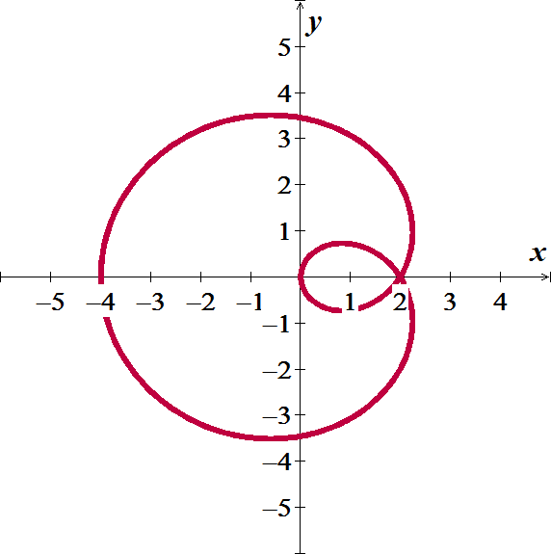

1.  is a limaçon, and  and  is a circle, and the composition of a limaçon and a circle is a limaçon.